FrameworkTwoPointO - Documentation and installation Guide

By Ryan Kruger

***Software Installation needed***

1. Intellej IDE
2. Java 64Bit
3. NPM
4. Appium
5. AVD Manager(Comes with android studio)

Varios java packages will be downloaded via Maven pacakage manager. Therefore it would be advised to have a good stable internet connection.

FramworkTwoPointO was written in JUnit format. Meaning the tests can be run from their respective classes and uses a format in which the class is executed.

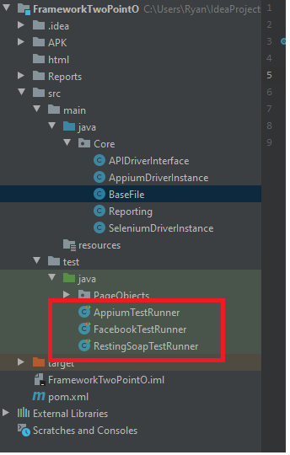

TheFacebookTestRunner -> Selenium JUnit Driver

AppiumTestRunner-> Appium JUnit Driver

RestingSoapTestRunner -> API JUnit Driver

To Run each of these tests right click on the part you want to run and click “Run”

***Pre-Requisites.***

1. Selenium(FacebookTest)

For Selenium to run a web test , you will need to download and install google Chrome.

1. Appium(AppiumTest)

* Download NPM
* Once NPM , open command line and run command:
* npm install -g appium
* Download Android Studio
* Open AVD Manager on android studio and create an emulator
* Change the Name of the emulator you are creating along with the android version.
* In the code under basefile: You should set the ’avd’ - which is the name of the avd you created in avd manager. If you are unsure run:

“emulator -list-avds” in command line and it will show you all the names.

The android version you are using should be entered into variable ‘andriodVersion’

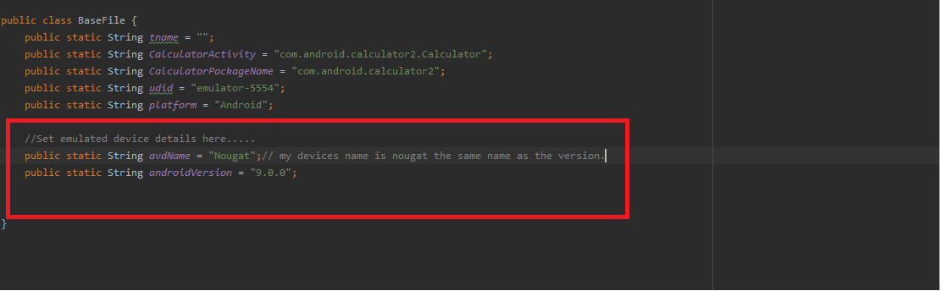

1. API(RestFullSoap)

For the API testing , I use java code to make a rest API Call and retreive data. I provided the api key.

***Reporting***

There is a Report folder at the base of the framework called “Repports” and each tests report will be stored there with in historical order. Sort it by date and time to get the latest ones.